Implementation summary
Group members: Niranjan K, Rohit A, Kian D

Brief project goal
The goal of this project was to learn object-oriented programming and how to use different libraries by creating a machine learning pipeline that automates the process of identifying different macroinvertebrate images. The crux of the system includes importing macroinvertebrate images from Kaggle hub, performing exploratory data analysis (EDA), training a classifier and then allowing a user to interact with the code by sending their own macroinvertebrate images through a console app.

Summary of system design
The system design consists of four main subsystems:
- The data handling
  - The data handling is done by order Kaggle hub image imports into raw data directory, images then used to create an indexed dataframe, image splitting and EDA
- Data predictions
  - Training the model, then having the option of single image predictions via console app and batch image predictions through the predict_test_images script.
- User interfaces
  - Contains the console app and the non-interactive full pipeline running mode
- Configurations
  - Contains the config script, gitignore, README, and requirements text file

Class and module overview
Class/module | File located in | Responsibility
ImageRecord | image_record.py | Holds metadata for images: file path, label, dimensions, channels
Classifier | classifier.py | Trains a Random Forest on test split images, saves a classification report and confusion matrix, also stores the model with joblib
DataProcessor | data_processor.py | Splits the indexed data frame into train and test sets
DatasetIndexer | dataset_indexer.py | Scans directory for image files with the suffixes defined in config
EDAService | eda_service.py | Generates and saves a distribution chart, image size histogram and a 3x3 sample grid
ImagePreprocessor | image_preprocessor.py | Loads an image converts it to greyscale, resizes it to 128x128, then normalises into a NumPy array
KaggleHub | kaggle_hub.py | Downloads the macroinvertebrate dataset from Kaggle hub into the raw data directory
WorkflowService | workflow.py | Coordinates the full pipeline (data loading, EDA and predictions)
Config | config.py | Defines all project directory paths, supported image files, and constants (image size)
ConsoleApp | console_app.py | The terminal menu that the user can interact with, running modules of the main pipeline manually
main | main.py | Contains the non-interactive, automatic full pipeline running mode
predict_test_images | test_predictions.py | Standalone script that loads the trained model and runs batch predictions on all the images in the test_data directory, printing the4 predicted macroinvertebrate and confidence score of each image

Tools and libraries used
Library/tool | Purpose
Kagglehub | Download of Kaggle hub datasets
Opencv-python | Image loading and manipulation
Pandas | Dataset management
Numpy | Array operations and matrix construction
Scikit-learn | Random forest classifier, accuracy score, confusion matrix and data splitting
Matplotlib | EDA charts
Seaborn | Data visualisations
Joblib | Saving and loading the trained model
Pathlib | Directory and image path handling

Key features implemented
Key features of the system include:
- Automated Kaggle hub dataset download
- Automated train/test dataset split
- Configurable output directories
- EDA graph outputs
- User inputted image prediction with confidence scores
- Interactive console menu that can run modules individually according to user demands or automatic full pipeline running mode.

Screenshots or example outputs
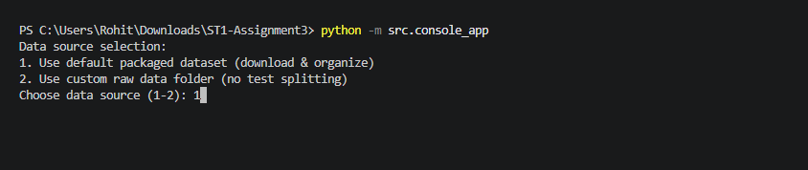
Figure 1 – picture of the custom output directory options (main file being displayed: console_app.py)
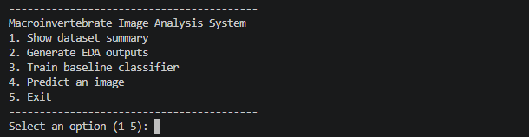
Figure 2 - picture of the main menu terminal (main file being displayed: console_app.py)
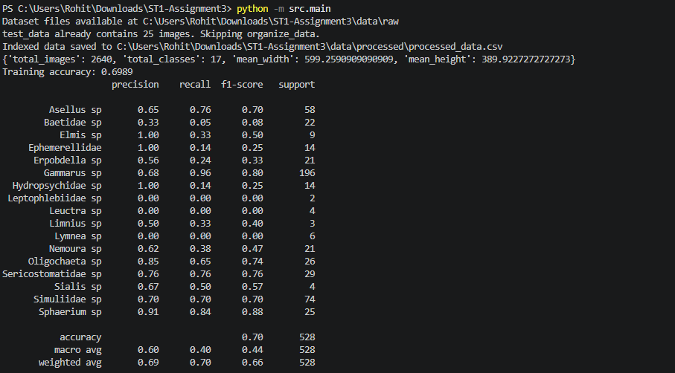
Figure 3 – the finished state of the automatic full pipeline running mode (main file being displayed: main.py)

Testing summary
The testing was conducted manual throughout the development of the project. Here is a list of things that were tested:
- DatasetIndexer correctly skips unsupported file types and unreadable images.
- ImagePreprocessor raises a clear ValueError for missing/unreadable image paths.
- WorkflowService correctly uses a default output directory when no custom path has been given
- ConsoleApp input validation rejects invalid menu choices, non-existent file paths, and invalid class names.
- The model produces consistent accuracy across runs.
- The full pipeline executes without errors on the packaged dataset and on a custom raw-data folder.

Acknowledgement of reused or adapted code
The following resources were used in the making of this project:
- scikit-learn documentation - RandomForestClassifier, train_test_split, classification_report, confusion_matrix usage patterns (https://scikit-learn.org).
- Seaborn documentation - heatmap and countplot examples used as reference for EDA visualisations (https://seaborn.pydata.org).
- OpenCV documentation - image reading, resizing, and colour conversion conventions (https://docs.opencv.org).
- kagglehub library - dataset_download API usage as per the official kagglehub README.
- Tutor given code – code was used and modified from here (https://uclearn.canberra.edu.au/courses/19234/files/6783303?module_item_id=1654596)

Work division among group members
Member | Student ID | Responsibility
Niranjan | u3319942 | Scaffolded the project together and put the tests and classes
Rohit | u3321763 | Worked on the Console app and its interaction with the project. Also worked on this report.
Kian | u3283545 | Prepared the Readme.md and helped with the presentation slides

